**Zmetrix**

**Controlled Impedance Test System**

**ST808**

6th Generation Performance …

Within your reach

****New 10 & 20 Ghz Bandwidths

****New On-Board Test capability

****New Insertion Loss Test Capability

****New High Bandwidth Probes

****New Active ESD Isolation

****Designed for Production Environments

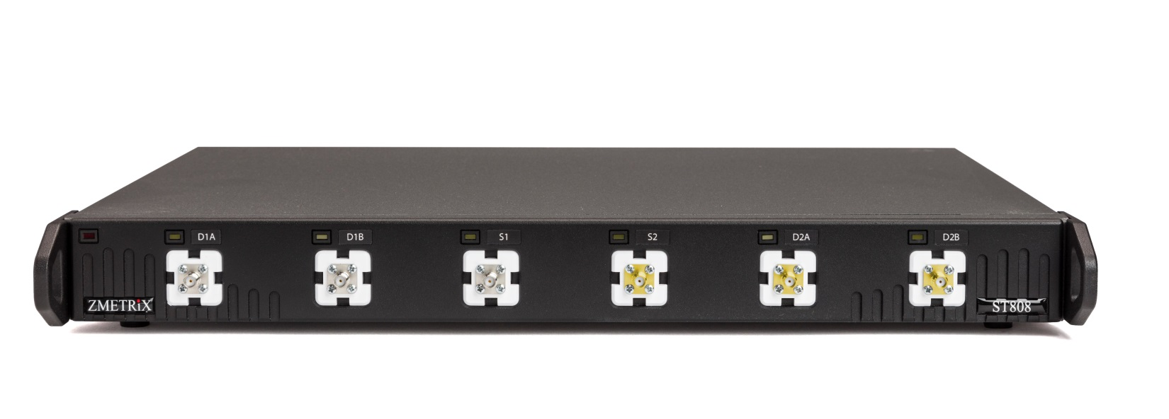

Controlled Impedance Test System Solutions

Zmetrix, Inc.

The New ST808 Hybrid

Controlled Impedance Test System

A new hybrid in TDR design, the ST808 contains not one, but two

TDR’s in tandem, to meet both present and future impedance **Production Grade**

measurement needs. The best of existing coupon measurements,

and the future of on-board and insertion loss measurements in Take the upgraded performance

in one easy to use tool. of a new 10 Ghz TDR, and mate

it with a new high bandwidth

ruggedized 20 Ghz TDR, and

The Zmetrix ST808 Controlled Impedance test system brings you have the new hybrid ST808.

New high performance TDR measurements to the production The single tool, all-in-one solution

Floor. In addition to an upgraded 10 Ghz TDR for traditional for all your TDR testing needs.

coupon testing, the ST808 incorporates an additional 20 Ghz Whether it’s high volume coupon

TDR for on-board and insertion loss testing. Both TDR’s testing, short-trace on-board

exhibit the same amazing ESD immunity as the widely recog- testing, or insertion loss testing,

nized ST600. Add to that a wide range of new, inexpensive the ST808 is uniquely suited to

probes for on-board and insertion loss testing, and you have meet all the demanding applications

the tool for all your impedance measurement needs. of a production line TDR.



Differential 1 Single 1 Single 2 Differential 2

10 Ghz Channels 20 Ghz Channels

Zscan Measurement Software

The Zmetrix ST808 comes standard with Win-

dows software that automates the data gather-

ing process through an intuitive user interface.

Calibration, verification, data logging, exporting,

And statistical reporting are all fully supported

by the software. Note – Insertion loss software

module sold separately.



Fixed Pitch

High Bandwidth

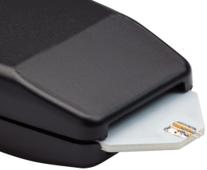Probes

The Zmetrix ST808 comes with a complete

line of low and high bandwidth probes for

making a variety of old and new measurements.

From fixed pitch coupon probing, to variable

pitch probing of BGA and fine pitch IC pads, to

insertion loss testing, the ST808 has a

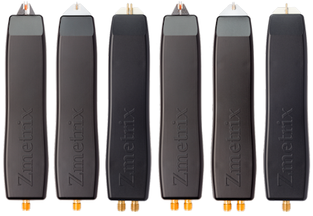comprehensive line of high and low bandwidth

probes to meet every need.

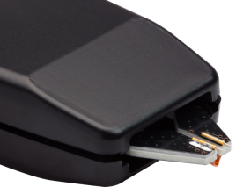

Variable Pitch

High Bandwidth

Specifications

Bandwidth 10 Ghz, 20 Ghz

Pulse Rise Time 75 psec, 20 psec

Channels 10 Ghz – 3, 20 Ghz – 3

Range 10 – 200 ohms

Accuracy 1% across the range

Impedance Resolution 0.03 ohms

Lineal Resolution 75 points/inch (0.013”)

Dimensions 17 X 14 X 2 inches

Weight 9.4 lbs.

Calibration 25, 50, 75, and 100 ohm Airlines

Traceable to national standards

Inputs

USB 2.0 peripheral port

Test probe channels – 6, SMA

Standard Accessories

50 ohm semi-rigid standard (qty-2) ACCST-211

100 ohm differential 10 Ghz probe IP-D-100-1-B

50 ohm single-ended 10 Ghz probe IP-S-50-1-B

100 ohm differential 20 ghz probe IP-D-HB-035

50 ohm single ended 20 Ghz probe IP-S-HB-035

High Bandwidth SMA Cable – 3 ft. (qty-3) CBL-104

USB Peripheral Cable – 6 ft. CBL-101

USB Footswitch ACCST-300

Anti-Static wrist strap & cable ACCST-301

Optional Accessories

100 ohm differential 20 ghz Variable Pitch probe IP-D-HB-VP

50 ohm single-ended 20 Ghz Variable Pitch probe IP-S-HB-VP

NIST traceable semi-rigid standards contact factory