ST800 Measurement Software

The Zmetrix ST800 impedance test system
comes standard with Windows software that
automates the data gathering process through
an intuitive user interface. Calibration,
verification, data logging, and statistical
reporting are all fully supported by the software.

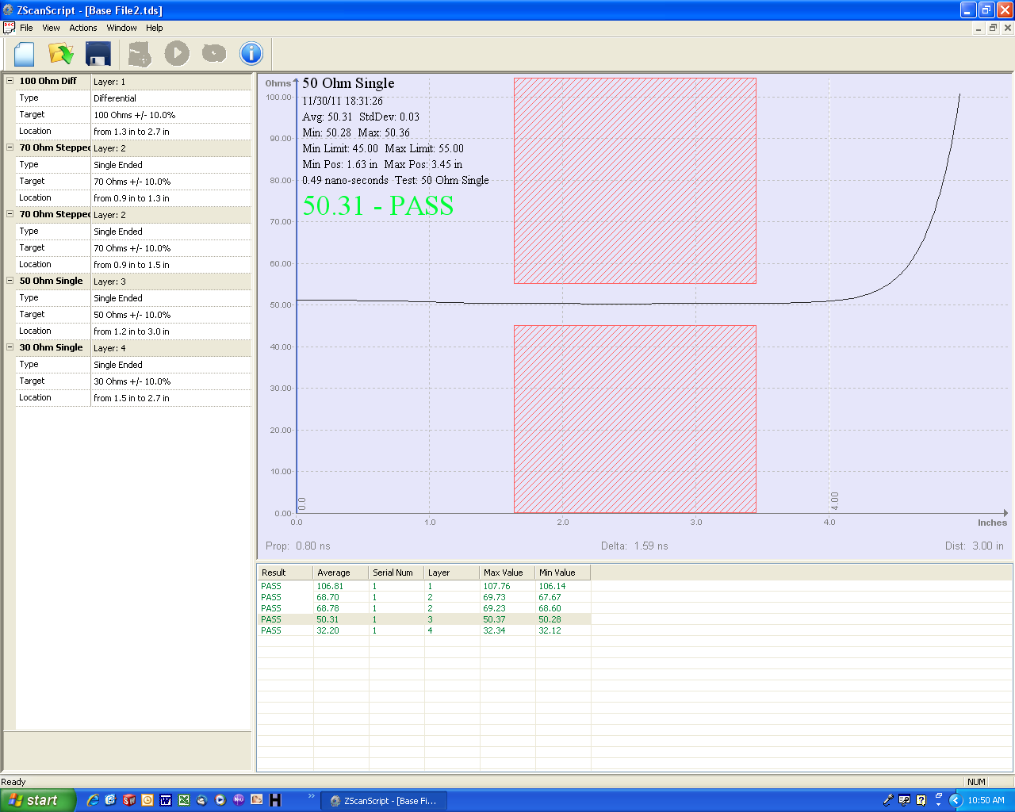
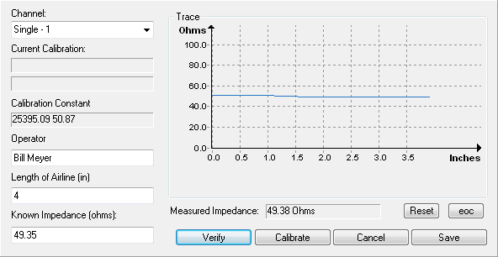

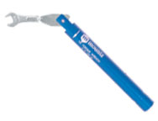
Standard Accessories

The Zmetrix ST800 ships with many standard accessories to
Help you begin taking production measurements. Semi-rigid
Reference standards, high bandwidth SMA cables, USB
Footpedal, and calibrated torque wrench are all included
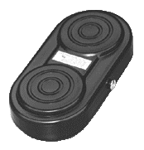
In the purchase price
ACST-311
SMA Torque
Wrench

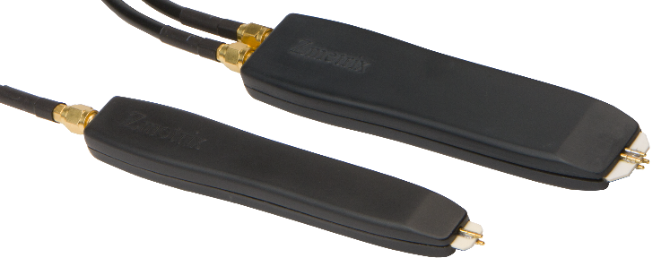
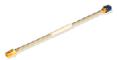

ACST-300
USB Footswitch

IP-S-50-1-B
ACST-211 50 Ohm Single Probe
50 Ohm Semi-Rigid Standard

