ST600 Measurement Software

The Zmetrix ST600 impedance test system
comes standard with Windows software that
automates the data gathering process through
an intuitive user interface. Calibration,
verification, data logging, and statistical
reporting are all fully supported by the software.

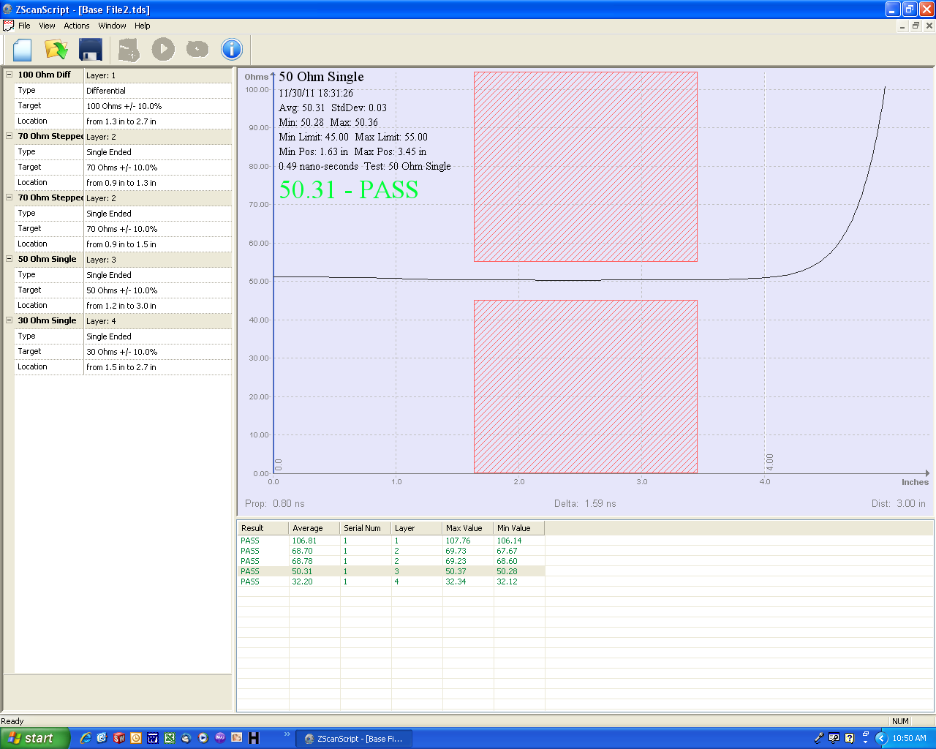
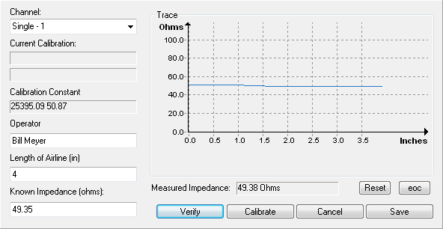

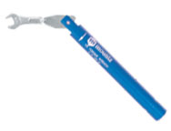
Standard Accessories

The Zmetrix ST600 ships with all the accessories you will
need to begin taking production measurements. From
foot pedal to semi-rigid standards, the accessories
you need are included in the purchase price.
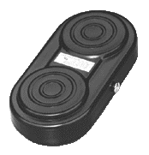
ACST-311
SMA Torque
Wrench

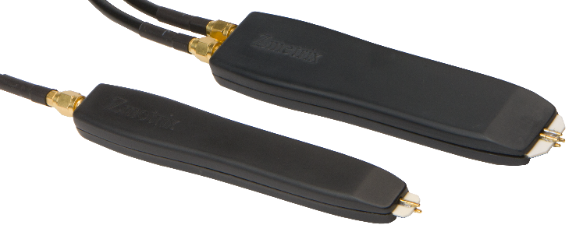
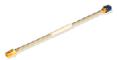

ACST-300
USB Footswitch

IP-S-50-1-B
ACST-211 50 Ohm Single Probe
50 Ohm Semi-Rigid Standard

