

**ST-SERIES TDR USER GUIDE**

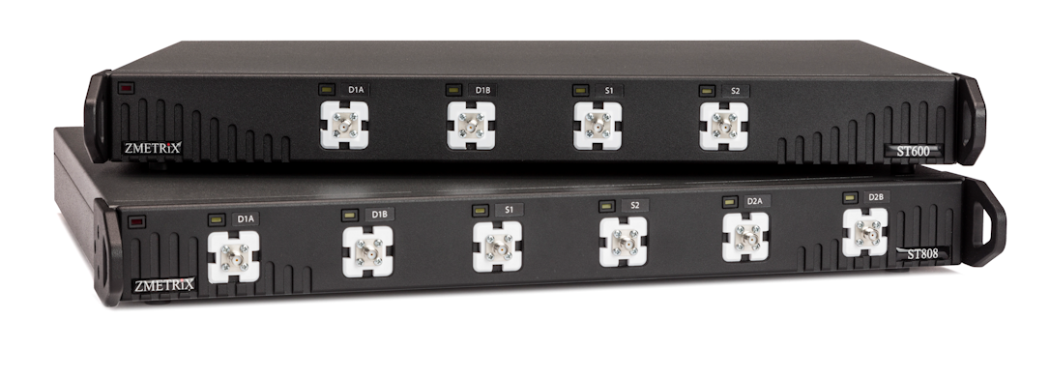

This manual can be used with all ST-series TDR’s

running ZScan **V 4.8.3**

Zmetrix Inc

1195 Spring Creek Pl., Suite B, Springville, UT 84663

801-489-8708 http://www.zmetrix.com

***Preface***

***Copyright***

Copyright © by Zmetrix, Inc. This manual and the hardware described in it are copyrighted, with all rights reserved. The manual may not be copied in whole or in part for any use without prior written consent of Zmetrix.

***Disclaimer***

The following paragraph does not apply in any state or country where such statements are not agreeable with local law.

Even though Zmetrix has reviewed its documentation, Zmetrix provides this publication “as is” without warranty of any kind, express or implied, including but not limited to, the implied warranties of merchantability or fitness for a particular purpose. This documentation is subject to change without notice, and should not be construed as a commitment or representation by Zmetrix.

This publication may contain inaccuracies or typographical errors. Zmetrix will periodically update the material for inclusion in new editions. Changes and improvements to the products and / or programs described in this manual may be made at any time.

***ST-Series Warranty, Installation, Service, and Repair Policies***

***Warranty:***

Zmetrix warrants ST-series controlled impedance test systems to be free from defects in material and workmanship for **two years** from the date of original purchase. During the warranty period, Zmetrix will repair, or at its option, replace any defective component(s) without charge for parts or labor.

The Zmetrix warranty applies only to products manufactured by Zmetrix. Accessories and items not manufactured by Zmetrix are covered by the warranty of the original equipment manufacturer. Product defects caused by misuse, accidents, or user modification are not covered by this warranty. No other warranties are expressed or implied. Zmetrix is not responsible for consequential damages.

***Installation:***

Installation of ST-series systems is not a technical or time consuming process. The ST-series are USB devices, and installation is primarily a software function. The ST-series comes ready to take measurements.

***Real Time Diagnostics:***

The ST-series continually generates a file named TDR.csv. This file contains a “snapshot” of the system electronics for the last measurement. In the event of a serious malfunction, e-mail that file to [www.zmetrix.com](http://www.zmetrix.com/) and our engineers will be able to diagnose system issues.

***A Note on Repairs:***

The typical repair for a TDR system is due to an ESD event originating at one of the input/output connectors. As part of the ST-series design, these events are dramatically reduced when compared to our competitors. Additionally, those same design features dramatically reduce the cost of a repair due to ESD.

***The ST-series***

The ST-series has SMA connections on the front panel. The configuration of SMA connectors depends on the number and type of channels that come with a particular ST-series model. The illustration below shows the configuration for an ST600 TDR.

**Communication** **Differential** 1. **Single** **2.** **Single**

**LED** **Ports** **ended Port** **ended Port**

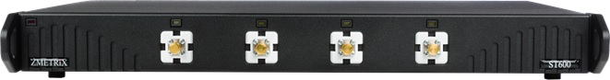

The USB port connects to a standard USB peripheral cable connection. The ST-series is compatible with USB version 2.0 or higher.

The ST-series systems are configured with multiple channels so that the user can take both single ended (SE) and differential (Diff) measurements without having to change cable connections. The SE and Diff probes can be left connected to the system continuously.

For high bandwidth systems (typ. 20Ghz), both high and low bandwidth connections are typical.

During test operation, the LED above the channel in use is illuminated.

The Zmetrix ZScan™ Software is designed for use within the Microsoft Windows environment. Windows XP through Windows 10 is assumed, running on an IBM-PC compatible computer with **USB 2.0** ports. The ST-series is controlled by keyboard and mouse. A foot switch is provided for “hands off” operation.

There is no wrist strap port on the ST-series. The supplied wrist strap should be plugged into any anti-static mat that might be employed.

***ST600 Specifications***

*Controlled Impedance Range 10 – 200 Ω Single Ended / 10 - 200 Ω Differential*

*Measurement Accuracy 1% of reading over the entire range*

*Impedance Tolerance Range 0.1 % - 99.9 %*

*Vertical Display Ranges (Ω) 1, 2, 5, 10, 20, 50 Ω / Division*

*Horizontal Display Ranges Infinitely adjustable to 30 inches*

*Testable trace lengths Maximum 30 inches - Minimum 2.5 inches*

*Horizontal Distance Units inches, feet, millimeters, meters*

*Horizontal Time Units Nano seconds, Picoseconds*

*Test Method Time Domain Reflectometry*

*Reflected Pulse Rise time ≥ 75ps*

*System Bandwidth 7 GHz*

*Calibration Method Ratiometric measurement to calibrated internal reference*

*Series Loss Compensation 0 – 5 Ω / inch*

*Vp Compensation 0.33 - 0.99*

*Channels 4, 2 single ended and 2 differential*

***Inputs and Outputs***

* **USB 2.0 (or higher) peripheral port**
* **Test probe channels – 4 (SMA)**

***Controls and Connectors***

***SMA Connectors***

The front panel SMA connectors should be connected to Zmetrix Micro strip probes using Zmetrix cables.



**CAUTION: Tighten with care***.* Use a torque wrench set to 5 lbf inches.

It is nearly impossible to get the SMA connectors tight enough with the fingers. Connectors that are not tight combined with the stiffness of the test cables can create erratic readings.

***USB2 Interface to the PC***

The host computer must have available a **USB 2.0 or higher** ports.

Any newer computer will have them. A USB 1.0 is not fast enough for the correct functioning of the ST800.

** IMPORTANT!** : Install ZScan and USB driver software prior to connecting ST-series to the host computer via the USB cable.

***ST808 Specifications***

*Controlled Impedance Range 10 – 200 Ω Single Ended / 10 - 200 Ω Differential*

*Measurement Accuracy 1% of reading over the entire range*

*Impedance Tolerance Range 0.1 % - 99.9 %*

*Vertical Display Ranges (Ω) 1, 2, 5, 10, 20, 50 Ω / Division*

*Horizontal Display Ranges Infinitely adjustable to 30 inches*

*Testable trace lengths Maximum 30 inches - Minimum 0.5 inches*

*Horizontal Distance Units inches, feet, millimeters, meters*

*Horizontal Time Units Nano seconds, Picoseconds*

*Test Method Time Domain Reflectometry*

*Pulse Rise time 20ps*

*System Bandwidth 20 GHz*

*Calibration Method Ratiometric measurement to calibrated internal reference*

*Series Loss Compensation 0 – 5 Ω / inch*

*Vp Compensation 0.33 - 0.99*

*Channels 6, 2 single ended and 2 differential*

***Inputs and Outputs***

* **USB 2.0 (or higher) peripheral port**
* **Test probe channels – 4 (SMA)**

***Controls and Connectors***

***SMA Connectors***

The front panel SMA connectors should be connected to Zmetrix Micro strip probes using Zmetrix cables.



**CAUTION: Tighten with care***.* Use a torque wrench set to 5 lbf inches.

It is nearly impossible to get the SMA connectors tight enough with the fingers. Connectors that are not tight combined with the stiffness of the test cables can create erratic readings.

***USB2 Interface to the PC***

The host computer must have available a **USB 2.0 or higher** ports.

Any newer computer will have them. A USB 1.0 is not fast enough for the correct functioning of the ST800.

** IMPORTANT!** : Install ZScan and USB driver software prior to connecting ST-series to the host computer via the USB cable.

***Anti-Static Wrist Strap***

While the ST-series is not overly sensitive to ESD, it is a good policy to wear the wrist strap when operating the system. The wrist strap can be plugged into any anti-static mat that you might be using.

Also, even if not strictly necessary it is always a good habit to prepare a proper environment for the instrument.

The following picture describes clearly a “perfect” working environment.

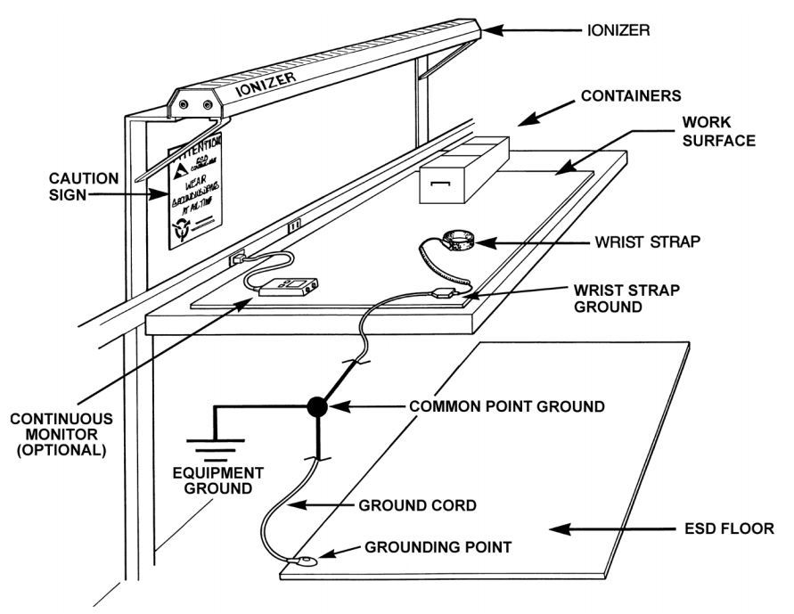

***Probes and Cables***

**Probes and cables should be considered to be consumables.** Like tires on cars, they are required for operation, but at some point they will need to be replaced.

***Cables***

The cables supplied with the ST-series are premium high bandwidth cables selected for the best electrical performance. Cables do wear out with repeated flexing over thousands of tests, test results can become erratic, therefor it is extremely important that the cables be electrically checked periodically. This is simple procedure, takes only seconds, and will save hours of grief.

The cables are expected to provide trouble free performance for hundreds of hours.

***Probes***

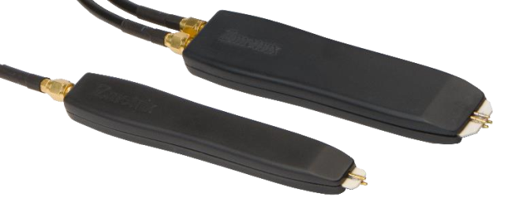

The ST-series is supplied with both single ended and differential probs. The interior of the probe is a Microstrip made of Rogers™ material and the spring loaded probe pins have been selected for optimal performances. Standard pin separation is 0.10” for low bandwidth probes, and 0.035” for high bandwidth probes. Variable pitch probes for both single-ended and differential High Bandwidth measurements are also available. Different pin spacing and/or configurations are available on special order. Unless you require a different pin spacing, these are the only probes you will need. In fact thanks to the high bandwidth of the ST-series, ***you can measure over the full impedance range with the same probe with full accuracy. No matching probes are required as in other competitor instruments.***

**Please do not attempt to repair the probe, it is a consumable! Measurements made with repaired or modified probes will not be guaranteed by Zmetrix.**

**Impedance measurements are polarity sensitive. The ground pin is the pin soldered to the copper side.**

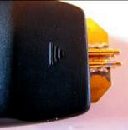

**This is the Ground Side.**

1. Overview

The ST-series needs to be connected via USB 2.0 or higher to any PC with Windows XP or higher. It has also to be connected to the power line.

Older versions of ST-series were powered directly by the USB port or with an external dongle. Newer ST-series have their own internal power supply and thus need to be connected to the power line.



Do not connect the ST-series to the PC before having installed the software and the drivers.

On the PC you need to have installed the proper Zscan software and the drivers supplied with the instruments.

1. Installation and set up

2.1 Unpacking

The ST-series is shipped in custom packaging. Please report any obvious damage to the carrier.

**Note:** We recommended saving the packaging for return of the instrument for annual re-certification.

The standard packaging should contain:

1 ST-series TDR

3 Probe Cables

1 USB Interface Cable

1 Single Ended low bandwidth Probe

1 Differential low bandwidth Probe

1 Footswitch

2 50 Ω semi-rigid standards

1 Torque Wrench

1 Anti-static Wrist Strap and Cable

1 A/C power cable

* Note - High Bandwidth models will also come with single, and differential probes standard

2.2 Controls and Connectors

***SMA Connectors***

The front panel SMA connectors should be connected to Zmetrix cables only. The connectors should be tightened with the supplied torque wrench. It is nearly impossible to get the SMA connectors tight enough with the fingers. Connectors that are not tight combined with the stiffness of the test cables can create erratic readings.

***USB Interface to the PC***

Use the supplied USB cable. Do not connect it before Zscan and proper drivers are installed on the host PC.

***Foot Switch***

The footswitch should be plugged into any available USB port on the host computer.

***Wrist Strap***

The ST-series does not have a socket to accommodate a wrist strap. Connect the supplied wrist strap to your anti-static test surface if you employ one.

***Power***

Connect the ST-series to the A/C power line using the included cable.

2.3 Getting Started

Go to [www.zmetrix.com](http://www.zmetrix.com/) and click on Download Software. Once downloaded, just run it to install on the computer.

The ZScan software will run on any version of Windows™ from XP through Windows 10™.

If you do not select a different directory, the installation will create a “C:/program files (x86)/Zmetrix Inc ” folder.

Everything you need is inside this folder.

Once the software is installed, you will find a Zmetrix icon on your desktop. Usually the required drivers are not installed automatically and thus you need to do it manually. Go to Windows Device Manager and locate the Zmetrix hardware (it will be under USB devices). Click on update drivers and direct the system to look for the drivers in C:/program files (x86)/Zmetrix Inc/Zscan.

2.4 Connecting the ST-series to the computer

Now that Zscan and drivers are installed you can connect the ST-series to the PC.

2.5 Running the program

Double click on the Zmetrix icon.

You should see the Zmetrix logo appearing in the middle of your desktop. The Zmetrix logo should remain on the dektop for few seconds. During this time the ST-series and the PC will exchange data. If the logo appears and instantly disappears, it means that data have not been exchanged and the communication is not active. You should investigate why the communication is not active. If all is OK you should see the main screen

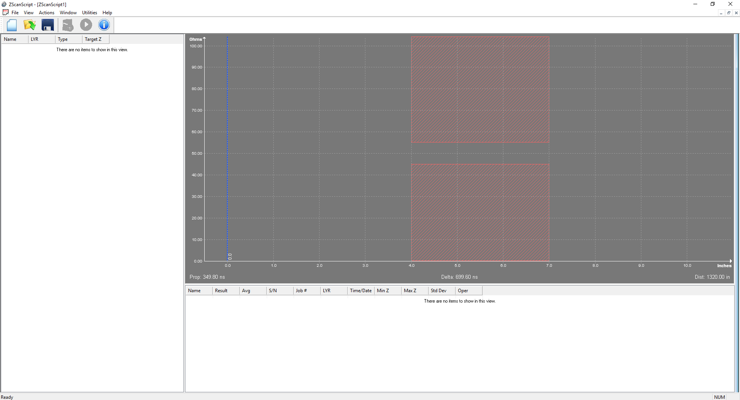

The screen colors may be different. This may be a good time to select the colors you prefer. Click on UTILITIES.

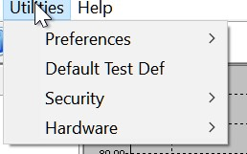

Select PREFERENCES and then COLORS.

You will be given the possibility to choose the colors you like for your main screen.

In PREFERENCES you can set not only the COLORS but many of the default configurations of the software.

We will list them here below. Some of them will be more clear further on this manual.

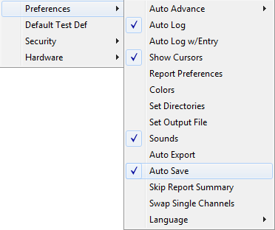

***Auto Advance***

In the testing process, once you have data logged, auto advance will advance to the next test. **There are three choices:** None, After test and After pass. We suggest selecting After Pass. Using this setup allows you several tries to make a good reading.

***Auto Log***

Selecting Auto Log will log the test automatically.

***Auto Log w/Entry***

Selecting Auto Log will bring up the log dialog automatically, and allow data entry.

***Show Cursors***

Two selectable cursors are available. The cursors are a screen tool used to help make measurements.

Example:

The cursors can be used to set test region.

The cursors can also be used to measure propagation times.

The cursor colors are selected in the Color Set utility.

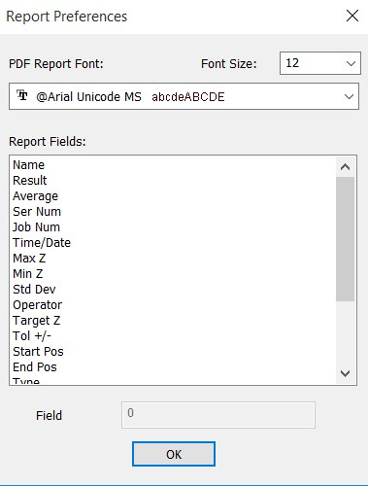***Report Preferences***

This table will allow you to set

the look and contents of your

report files.

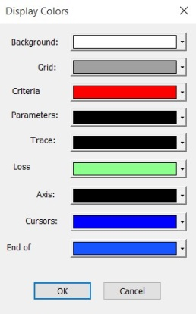***Colors***

Set the screen colors

to your preferences.

***Set Directories***

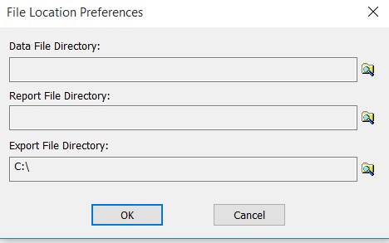

In this window you can select the default directories for the files that you will generate and save.

***Set Output File***

The **output file** is an important file that contains all of the diagnostic info for system. Every time you test, that file is overwritten with the latest system information. This file is labeled as default as **tdr.csv** and you should store it in a directory that is easily accessible. If you will experience problems with the instrument and call Zmetrix for assistance, this is the file Zmetrix customer service wants to see. With this file we can determine the “health” of the system (calibration, static damage, etc.) within minutes.

***Sounds***

Turns system sounds on / off (pass / fail).

***Auto Export***

It creates a delimited data file which can be exported. This saves an export file after every measurement. The export file works with third party databases.

***Auto Save***

It saves the “.tds file” automatically after every measurement.

***Skip Report Summary***

This removes the summary at the top of the report

***Swap Single Channels***

This allows swapping the two single ended Channels. If for any reason, a single ended channel is damaged, the other single ended channel can be used to continue testing. Normally this would require editing all the test files for the new channel number. The ‘Swap Single Channels’ option allows the user to make the change without editing any of the test files. All the files that have the old channel in the definition will now use the swapped channel

***Language***

Zscan software currently supports Korean, Chinese Traditional, and Chinese Simplified languages.

***Default Test Def***

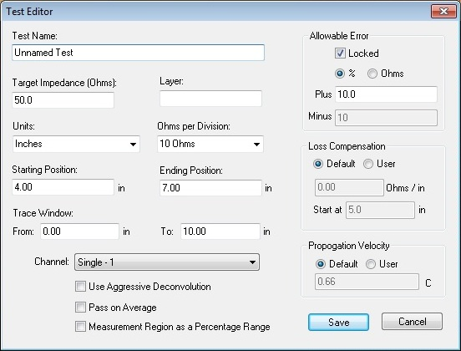

The **Default Test Def** function allows you to set certain parameters which are not likely to change from program to program, thereby saving test programming time. For instance you may want to set millimeters as your standard unit, or you want to set a standard for starting and ending position. This window is exactly the same of the test programming window and thus all its fields will be explained in details in following chapters. Every value stored in this **Default Test Def** window will be prompted as default value at the opening of the TEST PROGRAMMING WINDOW.

1. Tool bar and Menu bar

3.1 The Tool Bar



The tool bar contains the most frequently used commands and they have a correspondent on the MENU bar.

We list them here below. Their meaning will be clearer in the following chapters.

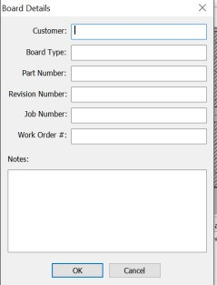**Clicking on** brings up

the new job screen. The same thing could

have been accomplished by clicking on File,

then New.

**Clicking on** opens the folder holding the test files (*.TDS).

**Clicking on**  saves the current job.

**Clicking on ** Logs the current coupon data. The same thing could have been accomplished by clicking on Actions and then on Log Coupon Data**.**

**Clicking on ** Toggles “live mode” and single test

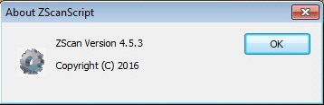**Clicking on ** Displays

The version of ZScan installed**.**

3.2 The Menu Bar

The menu bar contains all possible actions you can do with the Zscan software. Clicking on each menu will open a pop up window.

***File***

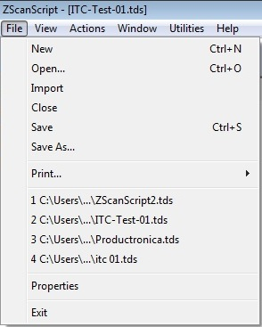

This window is similar to a standard generic Windows File. You can do all most common operations on files.

***View***

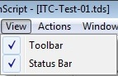

This popup window will allow you to view or hide status bar and menu bar.

***Actions***

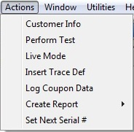

This window will bring up options that are explained later in this document.

***Window***

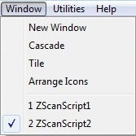

This window allow you to control the active windows in Zscan. With Zscan you can open multiple test windows and rearrange them as you wish. You can keep them open and use one of them without losing the test data on the others.

***Utilities***



As described on page 10.

1. A guide to Zscan

The ZScan software is intuitive and easy to use when you have an understanding of the basic screen layout. Please take a few moments to familiarize yourself with the location of the various functions.

The main screen is divided in three main areas



MEASUREMENT SCREEN

DATALOG PANE

TEST LIST

4.1 The Test List Screen

In the TEST LIST screen you will find the list of all test programs included in the current coupon in use. Here is where you will generate new programs or edit existing ones.

4.2 Datalog Pane***.***

The DATALOG Pane will show the list of your tests with all data. Zscan offers different levels of saving data. They will be explained later on this manual.

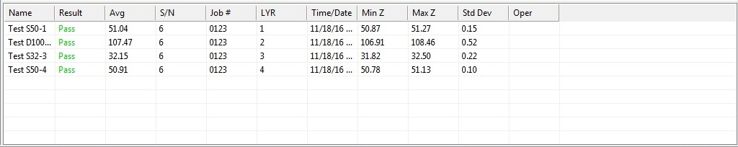

* 1. ***Main Test Screen***

The MAIN TEST SCREEN is where you will see the result of your last test.

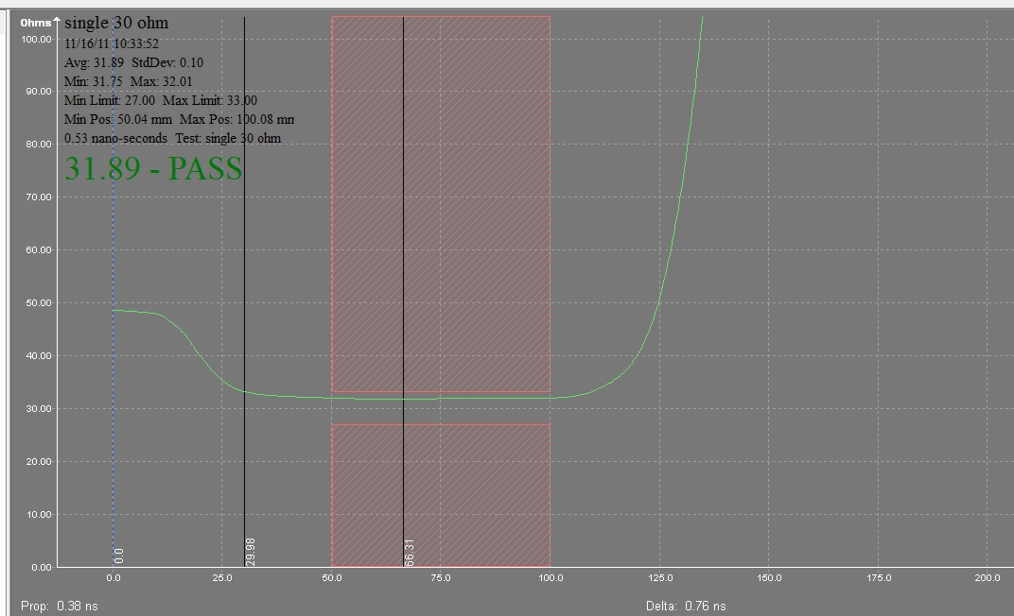

➐ ➍ ➏ ➌ ➎ ➋ ➊ ➑

➊ - waveform

➋ - testing area

➌ - cursors

➍ - end of probe line

➎ - data summary

➏ - result of test

➐ - impedance axis

➑ - length axis

1. ***Actions***

We will explain here the Actions menu. Clicking on Actions on the tool bar displays this dropdown menu.

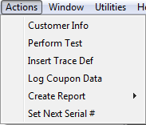

***Customer Info***

Clicking on Customer info allows you to enter your customer data. This is “Your OWN Company” data and they will printed on all reports.

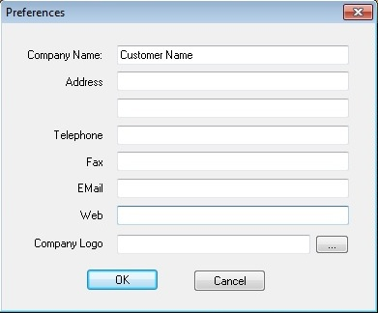

***Perform test***

This is exactly what it implies. Depress the footswitch or left click with the cursor in the Test screen or click on Actions/Perform Test or hit Enter any of these actions will initiate a single test.

***Insert trace def***

This opens test editor. Test editor can be opened by right clicking with the cursor in the test list pane, or hitting F4. Full explanation will be given in following chapters.

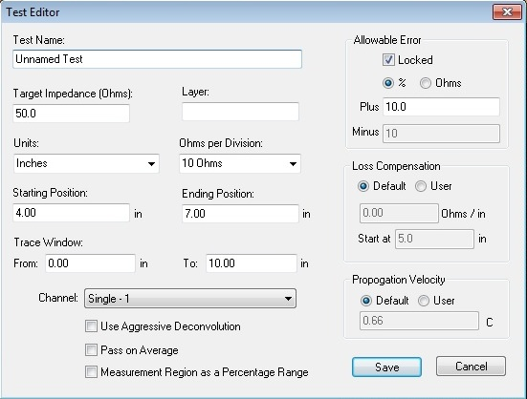

***Log coupon data***

Logs the data of the current coupon.

***Create Report***

Generates a .PDF report using current Datalog data. Select Full or Incremental report.

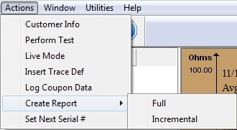

***Set Next Serial #***

Allows you to set a new serial number Serial numbers are automatically sequenced. This allows the user to set the next serial number**.**

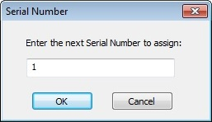

1. ***Utilities***

We will explain here the Utilities Menu.



***Preferences***

***Auto Advance***

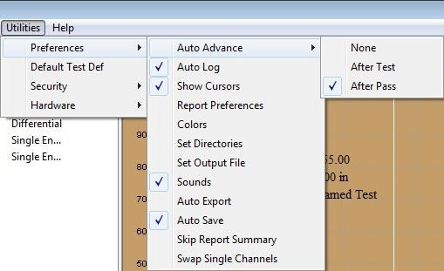

Provides three choices, None, After Test and After Pass. Recommended setting is After Pass. This provides the opportunity to retest if necessary before advancing. The test sequence will be advanced to the next test upon data logging**.**

***Auto Log***

Automatically log the test.

***Auto Log w/Entry***

Automatically brings up the log dialog, and allows data entry.

***Show Cursors***

It shows the 2 cursors on the waveform. Selects or deselects cursors

***Report Preferences***

The report can be customized by selecting the font of your choice and selecting the font size. Column widths can be widened or narrowed by clicking on a field name selecting the field width in the window below.

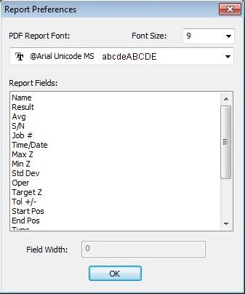

***Colors***

Clicking on colors allows you to change all the screen colors.

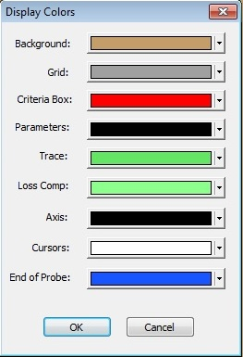 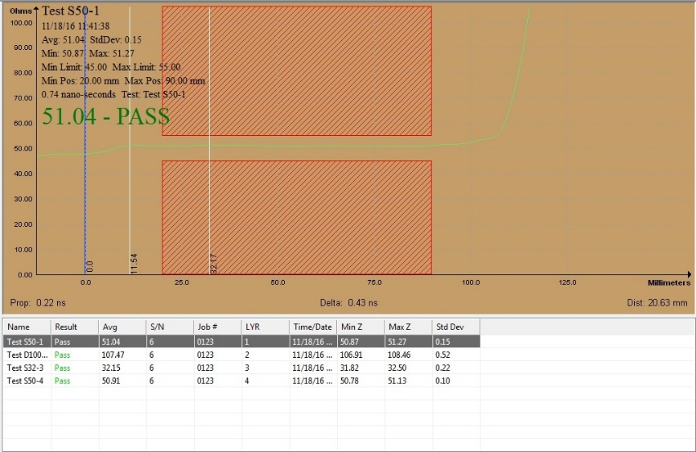

***Set Directories***

This popup allows the user to select the directories, for data logging and reports

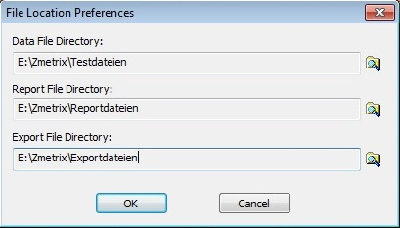

***Set Output File***

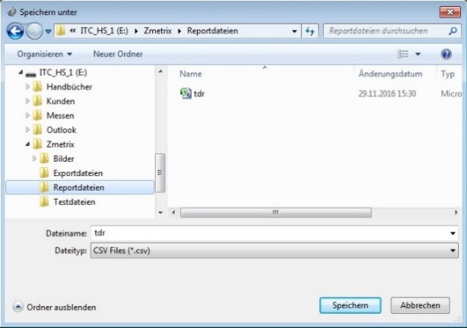

This file is one of the most important files in the system.

The **Output File** contains all of the diagnostic info for system. Every time you test, that file is overwritten with the latest system information. This file is labeled **tdr.csv** and you should store it in a directory that is easily accessible. If you encounter problems and call Zmetrix for assistance, this the file Zmetrix customer service wants to see. With this file we can determine the “health” of the system (calibration, static damage, etc.) within minutes.

***Sounds***

Set pass/fail sounds

***Auto Export***

Creates a delimited data file in .clf format for external use.

***Skip Report Summary***

This option truncates the report, leaving the summary info out.

***Swap Single Channels***

This option allows to swap the two Single Channels. It may happen that a lot of programs have been written to be tested on SE#1. But for some reasons the SE#1 is not available.

You can still use the SE#2, but you should re-edit all programs to change them to SE#2. This function makes this easier allowing you to swap SE#1 with SE#2, thus making no longer necessary the re-editing of the programs.

***Insert Test Definitions***

It will be explained in the next chapter.

***Security***

Security is for:

* Login
* Logout
* User manager

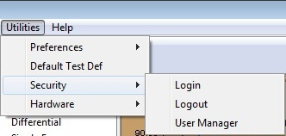

***User Manager***

Clicking on User Manager and you will see the screen below:

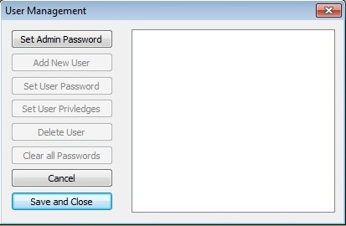

First you have to set the Admin Password. Clicking on Set Admin Password and you will see the screen below:

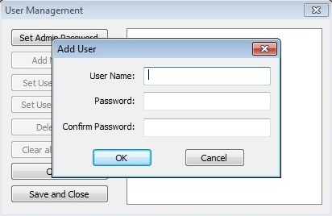

Enter a User Name and a Password and click on OK.

Now new Users can be set.

***Hardware***

A full chapter will be dedicated to this function later on this manual.

1. **WINDOW**

Here we will explain the WINDOW menu. Clicking on Window initiates this popup:

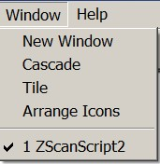

This feature allows you to view more than one test at a time. Note that the 2 tests are different. Zscan allows you to manage multiple windows and keep open more than one test at a time without losing data. The instrument will operate according to the active window.

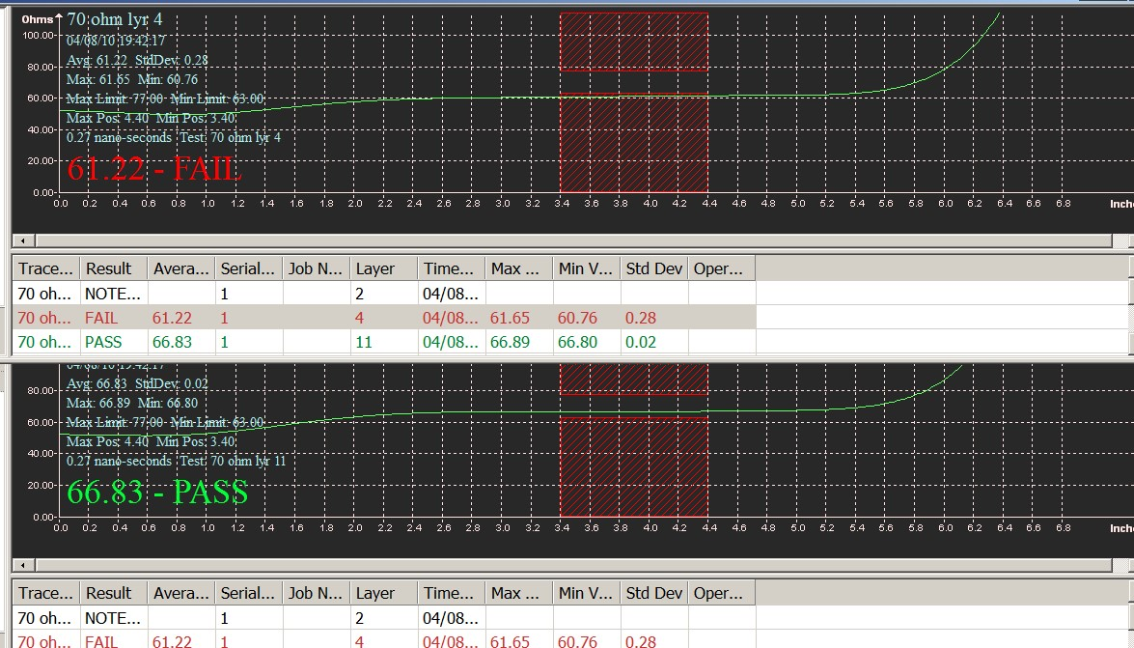

Clicking on New Window adds another window.

The windows can be cascaded.

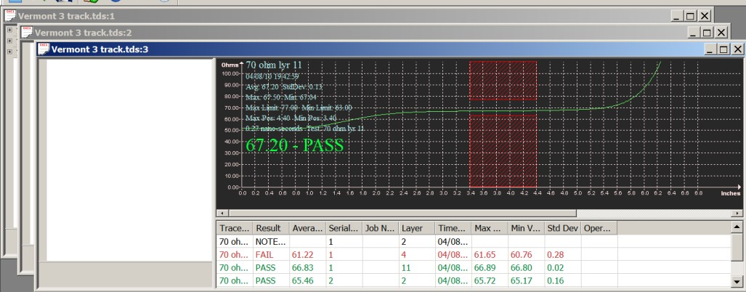

Or Tiled

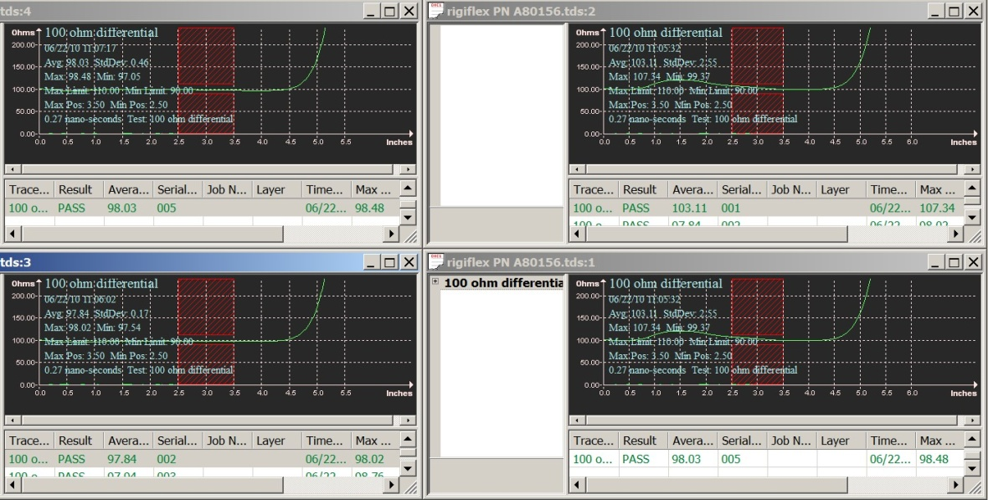

1. ***How To Program a Coupon***

Making a test program is one of the most important operations and thus we have dedicated an entire chapter to it.

To create a test you need to access the Test Editor window that can be done in different ways:

1. Through the menus : ACTIONS > INSERT TRACE DEFINITIONS
2. By mouse, positioning the cursor on the TEST LIST screen and pressing Right Click and INSERT.

This will bring up the TEST EDITOR

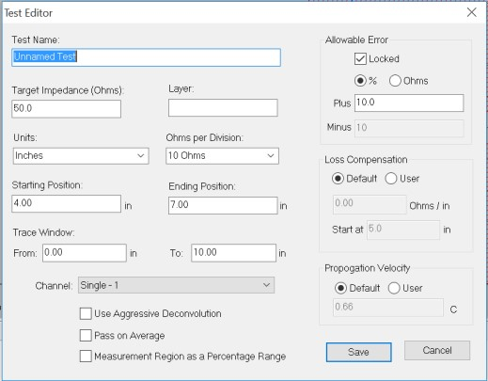

We will explain this window in detail, but before proceeding you have to notice that this is the same window that opens when you select UTILITIES>DEFAULT TEST DEF.

The 2 windows are exactly the same, thus the explanation for one is also valid for the second.

The only difference is that when you fill up the DEFAULT TEST DEF window, all values entered, will not create a test program , but they will be saved as DEFAULT values.

Thus every time you will open the TEST EDITOR, all fields will be pre-programmed with the DEFAULT values.

It is therefore recommended to set the DEFAULT TEST DEF at the beginning of using the Zscan sw.

***Test Name***

This is the name you want to give to your test program. Usually it should contain the info that allows you to easily recognize the test program. For instance “Single 50 ohm layer 1 “.

Please note that by “test program” we identify one specific trace to be tested. In a coupon there could be more than one trace to test. Each trace will have its own test program.

***Target Impedance***

This is the expected value of impedance for that track. This value will be used to center the tolerance around it and also all graph will be automatically sized around this value.

***Layer***

This is just a reference for operator and will be printed in the reports. It doesn’t affect the measuring in any way.

***Units***

This allows you to select the most convenient measurement unit in your country.

***Ohm per division***

This is allows you to control the scale on the Impedance axis.

***Starting and Ending Position***

These are 2 important values. They define the part of the waveform that will be considered for the pass/fail evaluation. The area is represented by 2 large red rectangles. You can see them in this picture.

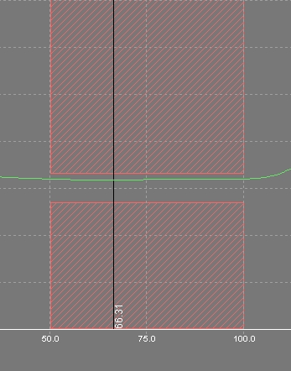

As you can see the starting point has been set at 50 mm, while the ending at 100 mm.

There is a specific reason why we need to set an area for the evaluation instead of using the complete waveform. The measurement of impedance by TDR is affected by discontinuities in the measuring line. This “noise” that is generated, could jeopardize the measurement specially at the beginning and at the end of the line. For this reason it is always recommended to use a central part of the line where the signal is stable. There is not a specific indication on what would be the best choice. IN each case the best choice is to choose where the signal is more stable.

***Trace Window***

These two values control the part of the graph that will be displayed. Unless required by particular conditions, it is strongly recommended to set values that allow you to see the complete waveform on the screen. Which means to set the “FROM” point at 0.00 (the origin of the graph) and as “TO” a value that is a couple of centimeters (one inch) higher than the expected length of the trace to be measured. For instance of your trace is 100 mm, set as “TO” = 120 mm.

***Channel***

Here you select the channel you want to use for your measurement.

***Aggressive Deconvolution***

Checking this box, you will allow the instrument to use the “Aggressive Deconvolution” function. This is a powerful statistical filter that will be explained in a separate chapter.

***Pass on Average***

Clicking this box you change the pass/fail evaluation criteria. Using standard criteria (this box unchecked), the waveform should go through the 2 red areas without touching them.

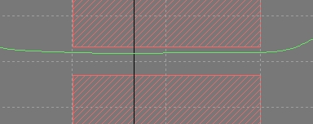

This means that no one single point of the waveform should fall into the read areas.

Using the PASS ON AVERAGE criteria, the waveform could touch the red areas and the test will be still given as GOOD, as long as the average value of impedance within the test area is still within the tolerance.

In order to show that you are using a different criteria, if this box is checked, the graphic will change in a red rectangle as follow :

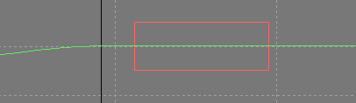

The PASS ON AVERAGE criteria is less stringent than standard criteria.

***Measurement Region as a Percentage of Range***

Clicking this box, you change the way you specify the starting and ending position. We have seen that you should specify them as starting and ending point. Clicking this box, you could specify them as percentage of the waveform length. It may result easier in some cases.

***Allowable Error***

This window gives you a complete control on the tolerance of your measurement.

For a given target impedance, you can set the maximum positive and negative error.

You can set it as “ohm” or as “%” of the target impedance.

You can use the same value for PLUS and MINUS if you leave the LOCKED selected, or you can specify different values , if you unlock it.

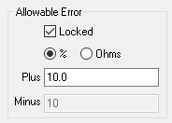

Graphically , this window will control the distance between the 2 red areas through which the waveform should pass.

***Loss Compensation***

This is also a special function that will be explained in detail in Chapter 15.

***Propagation Velocity***

This value is set as default at 0,66C which means at 66% of the speed of light.

This value represents the speed at which the electric signals travel through the media you are testing and in most cases is 0.66C.

However , it may be that you need to test coupons where the signal speed is significantly different. The speed of a signal through a media (for instance a cable or a PCB trace) depends on several factors and not only by the material the cable/trace is made. For instance one of the most influencing factors is the dielectric around the conductor.

Testing with a ”wrong” speed doesn’t make any influence on the values of Impedance collected, but it could make a big difference on the length of the trace seen by the instrument.

Operator thus, may want to readjust it to get graphs closer to actual trace length.

***Creating a Test Definition***

Once all parameters have been set to the desired values, clicking on save a new test program will be generated and it will appear on the TEST LIST pane.

Because a coupon is generally made by more than one test , it is possible to create additional tests in the same way. Unlimited number of tests can be inserted in the same coupon.

***Editing a Test Definition***

Right clicking on a test definition will open the following window.

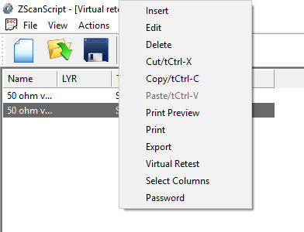

Here it is possible to make the usual Editing operations on the selected files (Edit,Delete,Cut,Copy).

For instance the copy function could result very useful to create a new test that is very similar to an existing one without having to reprogram the whole test.

It is also possible to have a print out of the test with a preview.

By EXPORT, you can export the test as .csv file.

By SELECT COLUMNS you can manage the columns you want to display in the TEST LIST pane.

PASSWORD is reserved to Zmetrix.

VIRTUAL RETEST will be seen later on.

1. ***Hardware***

We will see in this chapter the meaning and use of all functions included in the HARDWARE menu.

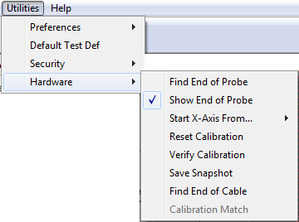

***Find End of Probe***

BY this function the system will check the length of the measuring chain from the internal hardware down to the probe tips. Before running this function you must ensure that a probe is connected to the cable. This function is recommended when you use different length probes or cable or when you start a system for the very first time.

***Show end of probe***

If you leave this line selected, you will see in the graph a blue line in the position of the end of probe.

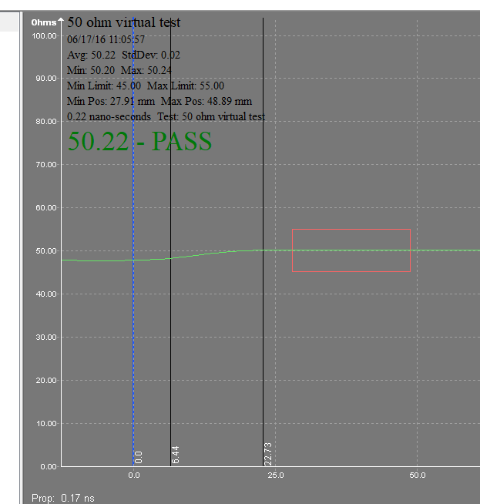

This line is very useful for the interpretation of the graph and avoid misunderstandings.

***Start X-Axis From***

There are 2 choices, End Of Cable and End Of Probe. Make sure that your selection is set to END OF PROBE.

If you set to END OF CABLE, you will see in the graph also the part of the waveform inside the probe.

This could be useful to check the status of the probes, but it may result in a wrong interpretation of the graph for what concerns the trace under measure.

***Reset Calibration***

By this function you will be able to bring the system back to original set ups as it left Zmetrix factory. This function is very useful as “Panic Button” when you did something wrong and you want to restore the factory set ups.

The set ups are divided by channels, thus you can recover just the channel you need.

A secondary method for archiving the entire flash memory of the unit is also provided. This memory file can be recalled into the instrument here as well.

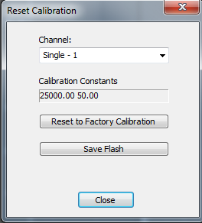

***Verify Calibration***

BY this function, you will be able to verify the system accuracy. A full chapter will be dedicated to this.

***Save Snapshot***

If you use this function you will be prompted to save a .csv file.

This is a diagnostic file that represents a picture of the status of the instrument.

You may be requested to use it during trouble shooting by a Zmetrix engineer.

***Find End of Cable***

This function will locate the electrical end of the cable for a given channel, and set the electrical end of that cable/channel as the zero point on the x-axis of the measurement window. To perform this function, the cable should not have any probe or accessory attached.

***Calibration Match***

This function allows the Zscan software to match the calibration of TDR’s from different manufacturers. Not all TDR manufacturers use a 4 point calibration with National Laboratory Airline reference standards. In these cases, the customer may want to see the data using the alternate calibration to compare data. This function will be examined in detail in a later chapter.

1. ***Making the First Test***

We are now ready to perform our first test.

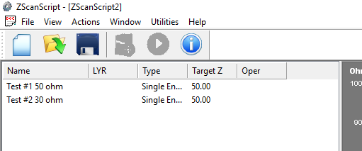

Suppose we have programmed 2 tests within the same coupon, as shown in above picture.

Both are Single-Ended, one with a target impedance of 50 ohms, and the second of 30 ohms.

This corresponds to 2 separate traces to be tested on the board. Both traces have to be tested to complete the coupon.

To start testing we need at first to select which test we want to use. This is done by clicking on the first test, and it will become highlighted.

Then we position the probe on the proper testing holes/pads.

Impedance testing is polarity sensitive, thus you must take care that the ground pin is going to the ground contact.

The ground connection can be different for each of the many different Zmetrix probe models, but often the ground side of the probe has been plated with gold. If the pin configuration is not clear, contact the factory for information on the probe model you are using.



**This is the Ground Side.**

When the probe is in position, we click with the mouse in any point of the grey area on the MEASUREMENT SCREEN and the test will be performed.

You can see the corresponding waveform on the screen along with all data collected.

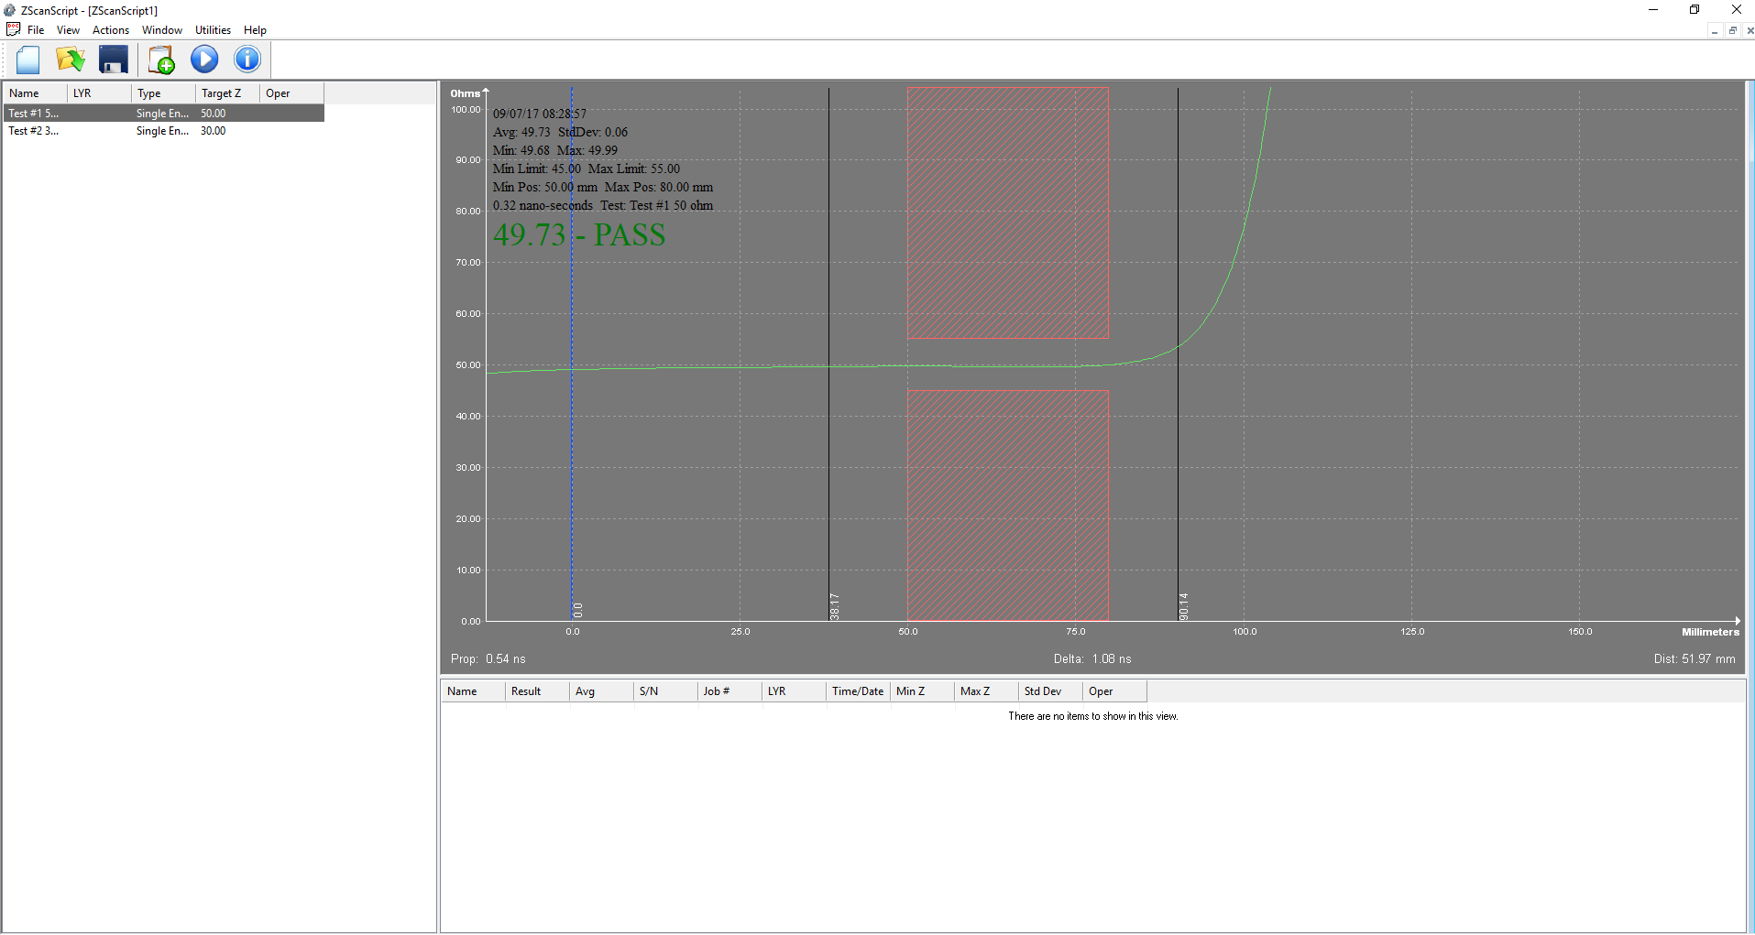

If we want to test now the second trace, we have to click on it , to highlight it and then , once the probe has been positioned on the corresponding trace, click again in the grey area.

And we will get our second measurement.

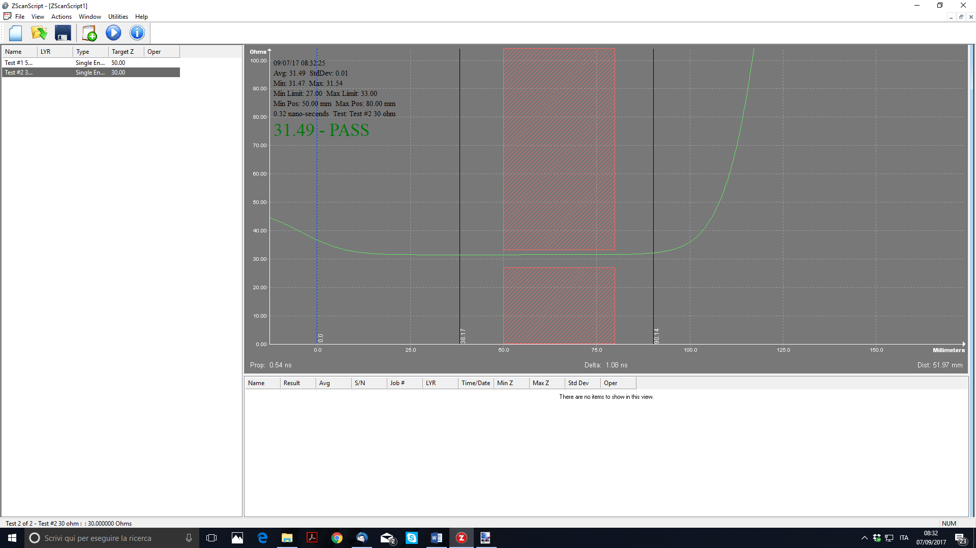

As we can see we have totally lost the information about the first measurement. It is now the time to learn how to save our measured data.

1. ***Saving Data***

It is very important to learn how to save data with your Zscan software. The Zscan software allows you to save data on different levels.

***Current Coupon***

The first level is called “Current Coupon”. It allows the temporary saving of the current measurement of each trace in the test list.

If we go back to our example , after we tested the first trace , we got this screenshot.



If I want to save it as “current coupon” in order to move to the second test without losing this test, I need to Right click with the mouse in the grey area.

I will see in the DATALOG Pane that a line will be added.

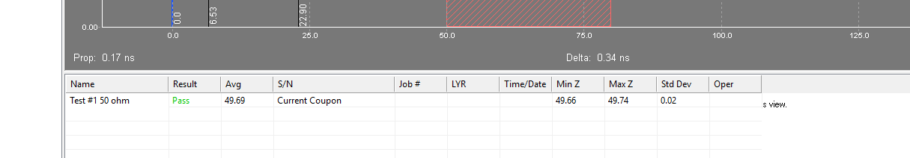

This line contains all the info of the test just done and it is labeled as “current coupon. Now I can highlight the second test and perform it. I will see the new waveform and as I did with the first, Right click on the grey area.

I will got a second line with the results of the second test also labeled as “current Coupon”.

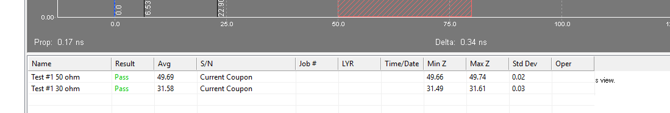

I have now completely tested my first coupon. My coupon was made by just 2 tests, but it could have been made by 3, 4 or more different tests. All work in the same way.

Now that I have finished my first coupon, I am ready to move to test my second board.

But I notice that if I try to do what I just did for the first coupon, all values collected for the first coupon will be overwritten. If I want to save them, I need to do a second level of saving.

***Log Coupon***

In order to save the data collected for the first coupon ( the first board), I need to perform the operation called “LOGGING OF THE COUPON”. The easiest way to do so is to press the icon



on the task bar.

I will be prompted with this window

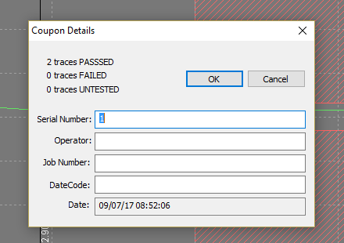

that I can fill up with proper information. On pressing OK, I will see that my 2 original lines in the DATALOG PANE will change as follow :

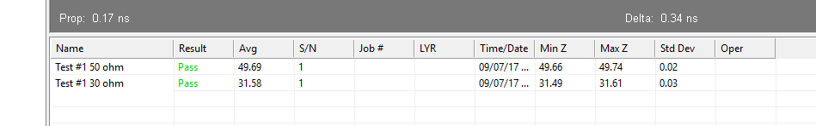

As you can see the 2 lines have been changed from “Current Coupon” to S/N number 1. This means that those data are now saved as Coupon #1.

If I test the next coupon and save as before I will create a new Current Coupon. After the test I will get this situation.

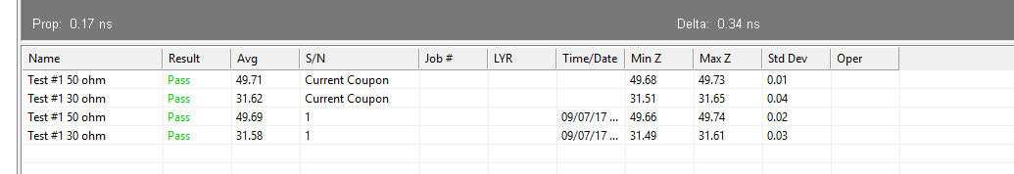

I can now log this second coupon and continue this way. Every new coupon will be saved as “current Coupon” until it is logged.

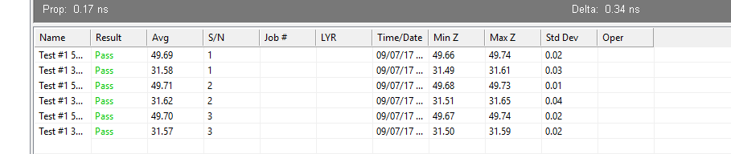

For instance in the above picture I have successfully tested 3 coupons ( 3 boards).

You may notice that if you click on anyone of the lines, it will show you the complete corresponding graph.

All trace data is now securely saved in my PC ? No! Not yet. The data is still only in the RAM memory of the computer, and thus if you switch off the computer at this time, you will lose your data. We need to learn a new level of saving.

***Saving the .tds file***

In order to save all my measurements, I need to use the “SAVE” or “SAVE AS…” functions on the FILE menu. When I choose to save I will be prompted to give a name and a destination and a file with extension .tds will be created.

This file contains all the data collected including all waveforms and all raw data collected by the instrument. Thus it is not just a summary of what has been done, but it contains all the information as just collected by the instrument for each one of the traces that has been tested.

This condition will allow the application of the “Virtual Retest” function that will be explained later on.

***Automating some operations***

We have seen that in operation, we need to highlight each test before performing it and at the end of each coupon we need to log it to move to the next. The Zscan software helps in automating some of these functions to make it easier to perform routine tests in a working environment.

The AUTO ADVANCE function allows the data colletion to automatically move to the next test, thus eliminating the need for clicking the required test. This function has been already explained, but to review, there are three options that can be set here:

* NONE = no automatic advance
* AFTER TEST = it moves to the next test regardless the result of the measurement
* AFTER PASS = it moves to the next test only if the measurement is OK

The most recommended is AFTER PASS.

In the same way, the function AUTO LOG automates the logging of a coupon.

1. ***Generating Reports and Exporting Data***

It is important to know how to generate a report for your customer.

A report is a summary of all tests done. To generate a report is very simple with Zscan.

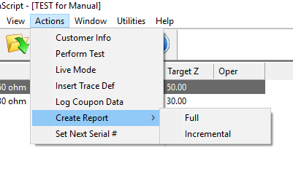

From ACTIONS menu, click GENERATE REPORT. You can choose of generating a full report or just a part if a job if a previous report has been already generated.

The report is a .pdf file of three pages containing all the collected data as well as the programming data.

Reports can be customized in PREFERENCES. 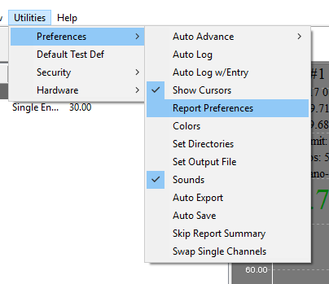

Often customers would like to have a lot of data in their report. If an end user requests a lot of data, the best way is to send him the original test file .tds. This file, as said, contains everything the instrument has collected from the boards along with the calculations made by the Zscan software. The end user can open this file by a Zscan copy that is free of charge and can see everything he needs.

***Exporting Data***

Various data can be exported from Zscan.

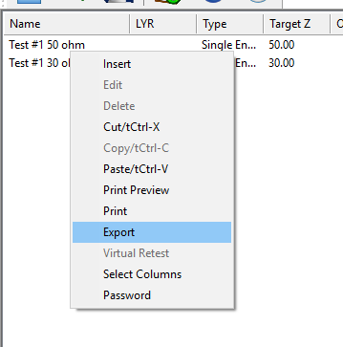

Right clicking on the TEST LIST pane, a pop up window will open. One of the item is EXPORT. By this function you will save a .csv file containing all the programmed tests with each own parameters. No test data will be exported.

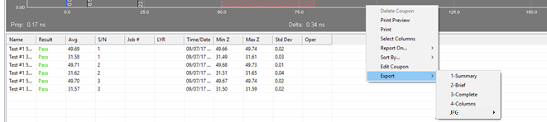

Right clicking on the DATALOG pane after some coupons have been saved , it will allow to export the entire results of tests. It is also possible to select what to export. In this case test data will be exported.

Note that .JPG picture files can be saved as one of the Export options. Individual traces or the entire data pane set of traces can be saved as .JPG files.

1. ***Virtual Retest***

Virtual Retest is a function that allows you to re-evaluate all your data after a modification of test parameters. For instance, you may have tested 100 panels with a tolerance of +/- 10%, but you realize that the requested tolerance was +/-5%. Zscan offers you the possibility to modify your test parameters and then re-evaluate all collected data based on the new set up without having to test the entire batch of boards again.

Let’s consider our example. We have tested 3 coupons with a tolerance of 10%. But I want to re-evaluate them changing the tolerance of the 30 ohm test to 1%.

What I need to do is to EDIT the relevant test definition.

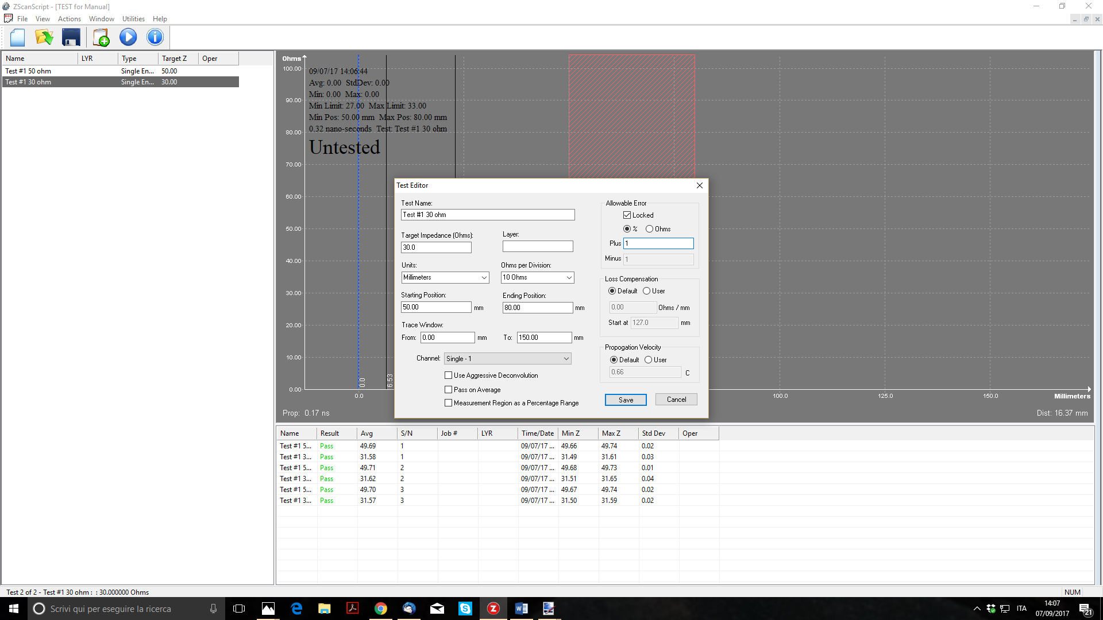

I simply change the Test #2 30 ohm tolerance to 1%.

After saving, I Right click on the Test #2 30 ohm line and access the Virtual Retest function

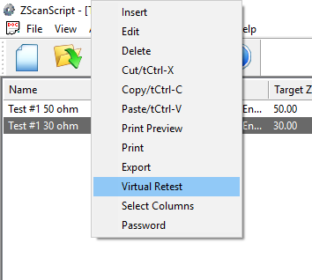

After confirming with YES to proceed, all 3 coupons will be re-evaluated. In fact as you can see that the 3 30 ohm lines all FAIL now because of the much tighter tolerance.

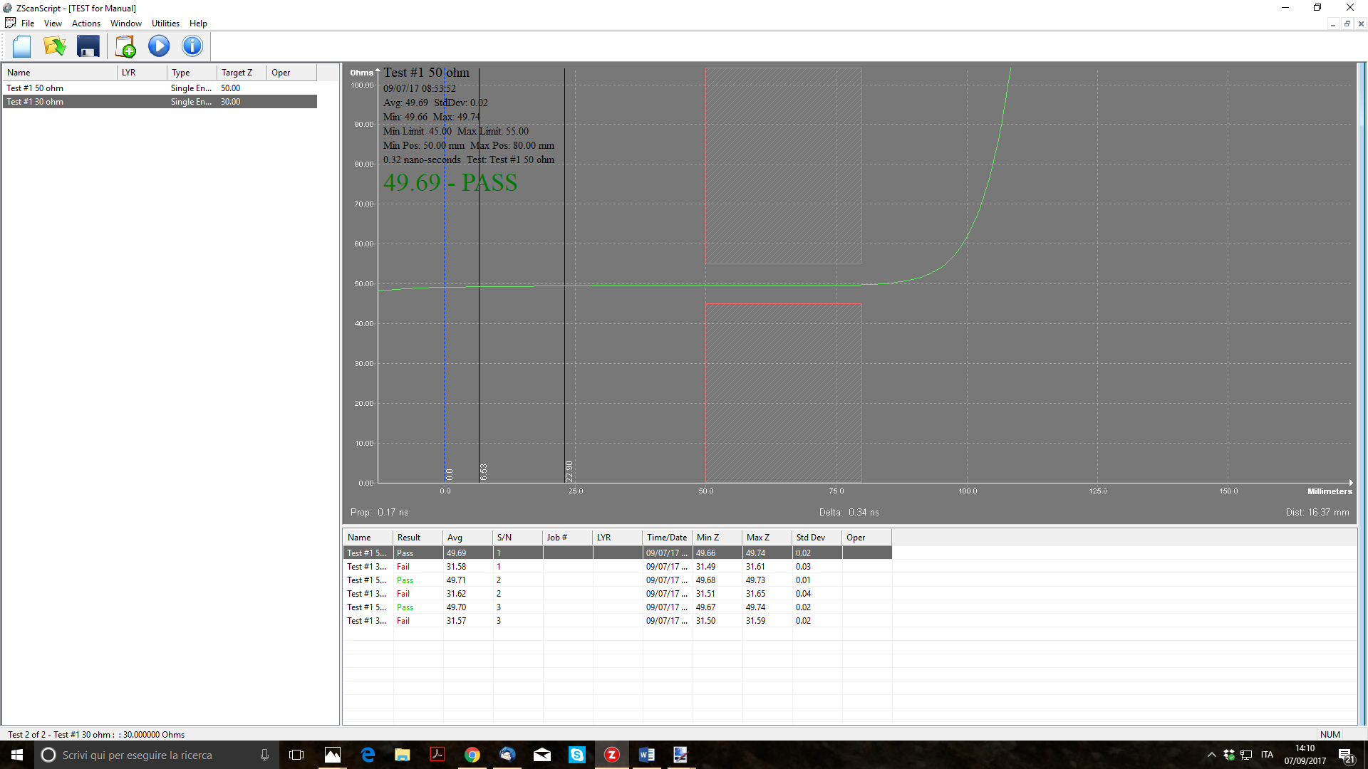

Any one of the defined tests can be changed and then re-evaluated.

1. ***Aggressive Deconvolution***

We will explain here in detail the use of the aggressive deconvolution function.

This function can be found in the TEST EDITOR page as follow :

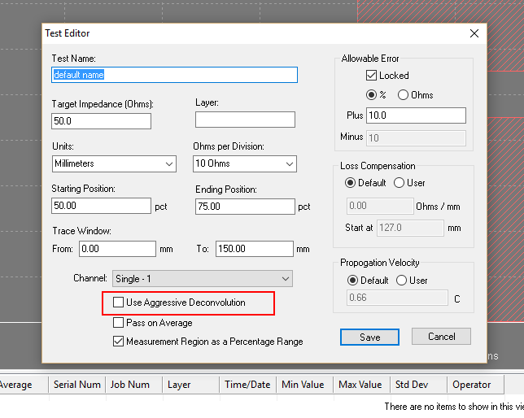

All TDR manufacturers use deconvolution algorithms to interpret the reflections that come back as raw data to the TDR. The general form of these algorithms is basic, and in the public domain. The specific form of the algorithm that is used by each manufacturer however, is proprietary to the manufacturer, and is one of the basic differentiators between TDR capability. In the case of aggressive deconvolution, Zmetrix has provided an option for aggressively finding short trace measurement values.

This function is very powerful but has also some downturns, as we will tell later on.

To show the potential of this function we will use a special coupon designed for this purpose.

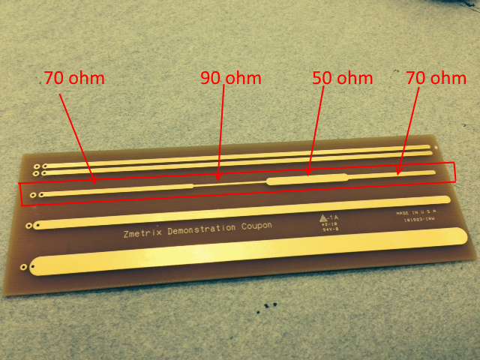

Let’s consider the special trace in the red square. As you can see this trace is changing impedance sharply along its length. The total length is about 5 inches (12 cm ). The first part (2”) is at 70 ohm, then it sharply change to 90 ohm for 1”, then go down to 50 ohm for another 1” and finally go back to 70 ohm for the last 1”.

The trace length is within the limit of the testing capability for the ST-series, but each portion of the trace is well beyond the testing capability of the instrument.

If we try to test this trace in the standard mode we will get this result.

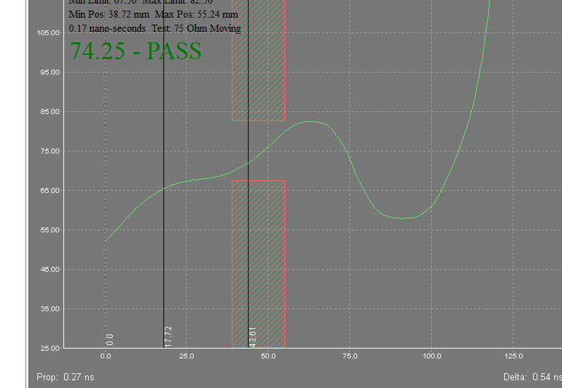

The instrument is already quite good to pick up such short and sharp changing in impedance, but we cannot say that the measurement at each step of the trace is reliable and stable. For instance, we can almost recognize the first three sections of the trace, but the last section is totally missing.

Let’s try now to measure again the same trace with the Aggressive Deconvolution activated.

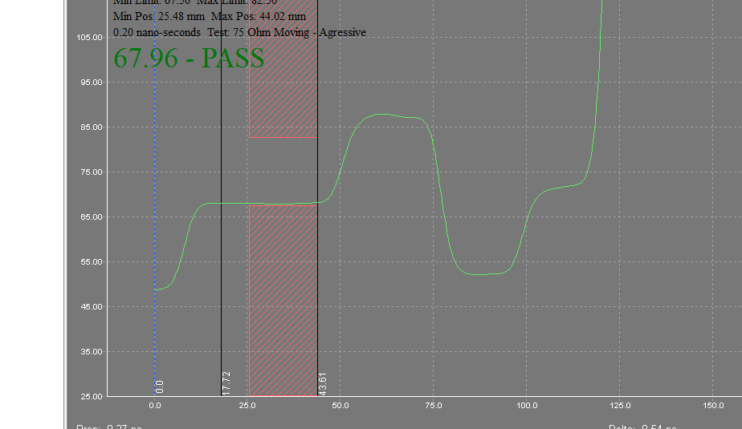

As we can see, the more aggressive algorithm is able to find stable measurements in each of the 4 sections.

Again, this improved method for finding short trace measurements has drawbacks that prevent it from being the algorithm of choice for all measurements, but it is well suited for improving short trace resolution.

***Advantages and Downturns***

We have just seen how the effect of the use of Aggressive Deconvolution can improve short trace resolution. Using Aggressive Deconvolution, you can try to test traces that are quite short in length, below the normal resolution of the instrument.

But we must always remember that this is an algorithm that targets short traces, and may obscure smaller variations in the data in favor of gross changes. An example of this is skin effect, which would not show up well with this type of algorithm. Any long, ‘slow’ change would be ignored in favor of sharp changes. For this reason, Aggressive deconvolution Is normally only used for improving the resolution of short traces (typically under 2.5 inches).

1. ***Loss Compenastion***

We will explain here in detail the use of the loss compensation function.

This function can be found in the TEST EDITOR page as follow :

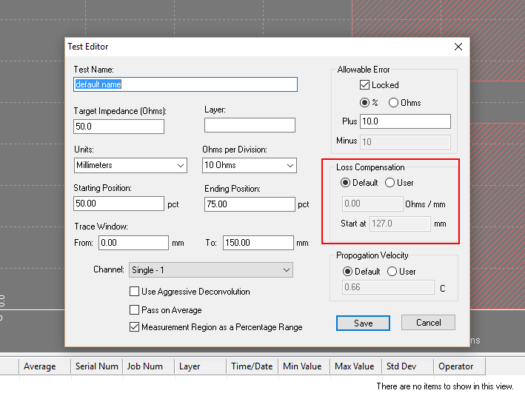

If set as “Default” the function will not be used. To use it , set as “USER” and the 2 lower fields will be activated.

We all know that in conductors , alternate currents trend to distribute in a non uniform way. This is an effect called “skin effect”. The current density in a section of a conductor is higher near the surface of the conductor and lower in the center.

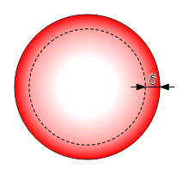

As result of this, the impedance of the conductor is higher than expected. This effect is negligible for large sections, but become important with small sections. For this reason, if in presence of the skin effect , the measurement of the instrument can be compromised. It is therefore important in these cases to have a tool to compensate this loss.

With the skin effect, the increase in impedance is linear and thus the waveform of the measurement instead of being flat is a slope. This is a measurement with such effect.

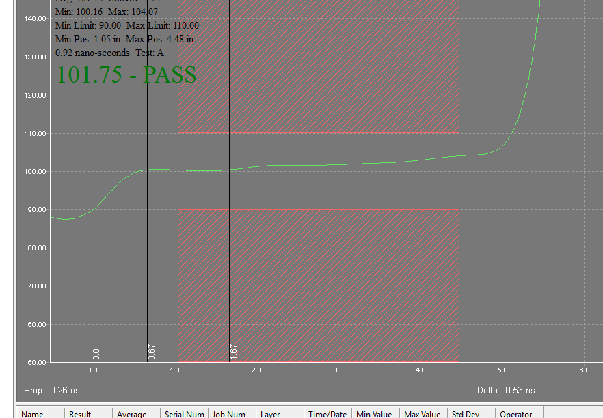

We have overwritten a yellow line to emphasize the slope

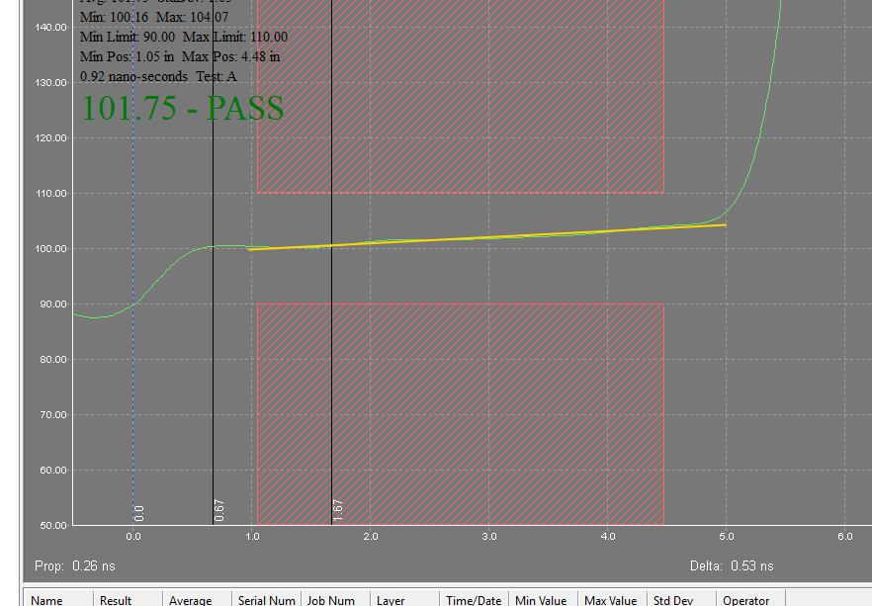

You can clearly see that the impedance at the end of the line is higher than the beginning due to the skin effect.

To use the compensation we need to get two values :

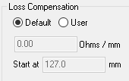

* The starting point (in mm or in)
* The variation by length (in ohm/mm or ohm/in)

To get these two values is easy.

The starting point can be easily identified in the graphic

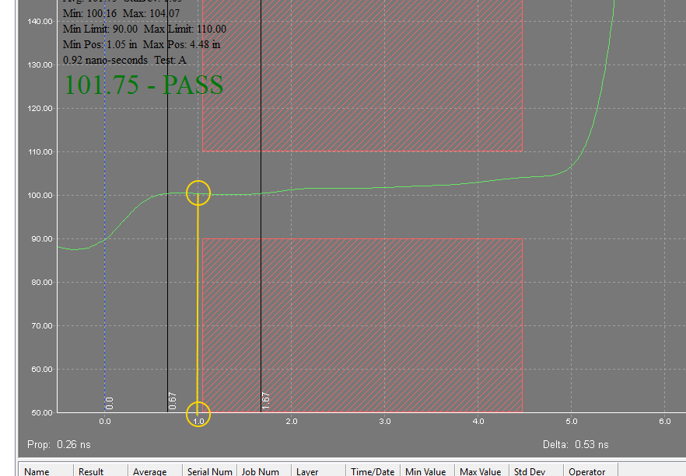

For instance in our example we see that we can start the compensation at 1”.

To calculate the variation by length, we need to check what is the value of the impedance at beginning and at the end of my testing area and how long is the testing area. As you can see in the following picture :

* Impedance at beginning = 101 ohm
* Impedance at the end = 105 ohm
* Delta impedance = 4 ohm
* Start point = 1”
* End point = 4,45”
* Delta length = 3,45”

Thus our variation by length will be : $/3,45 = 1,159 ohm/inch

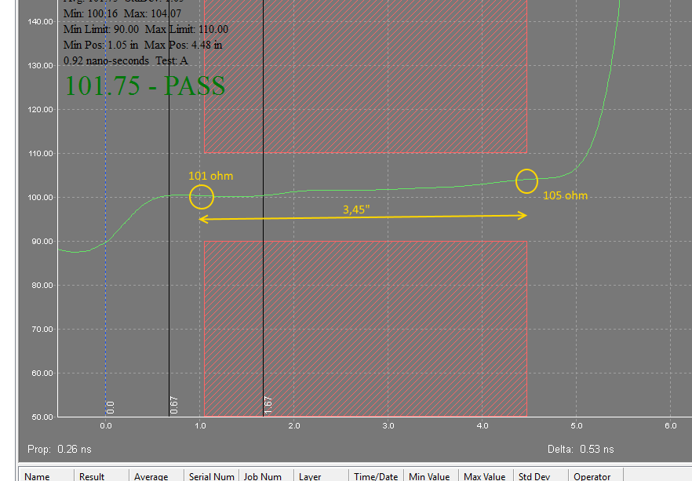

So we can enter now our two values :

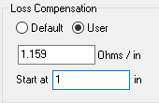

When we will apply it, this is what we get

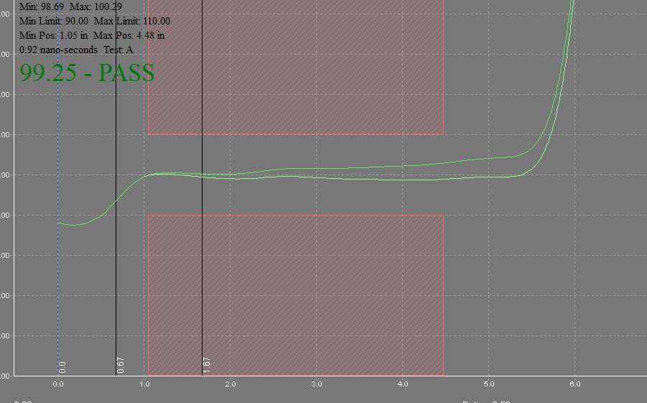

As you see , you will get 2 waveforms, the original plus the compensated one.

The PASS/FAIL will be calculated on the compensated one.

1. ***Calibration***

ST-series TDR’s are very precise instruments. The accuracy of the ST-series is 1% anywhere in the measurement range (20-200 ohms), and it has been calibrated by Zmetrix using 4 reference points based on international laboratory airline standards (25, 50, 75 and 100 ohm).

ST-series TDR’s also use internal references to calibrate each measurement, and do so in a more complete way than is possible for the end user. Each measurement is adapting, and re-calibrating to account for small changes in temperature, humidity, micro ESD damage, etc.. For this reason, there is no need for the user to calibrate these instruments. What is recommended though, is that the user periodically do a verification of the accuracy of the TDR.

***Verify Calibration***

In normal operation the verify calibration is enough for your daily routine.

To make verification for the Single Ended Channels, click on Utilities/Hardware/Verify Calibration.

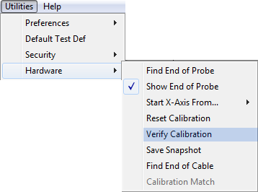

Click Verify Calibration to bring up this screen:

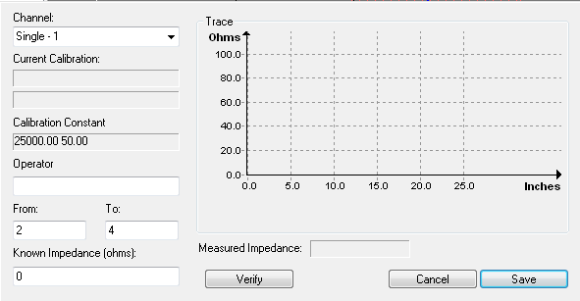

To verify the accuracy of a channel, use the following steps:

1. Select the ‘Find End of Cable’ function on the Hardware menu. Make sure to select the correct channel, and then press ‘OK’. The software will prompt to make sure nothing is connected to the cable.

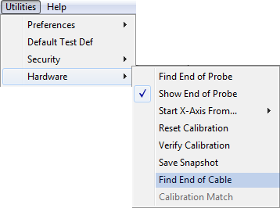

1. Attach a semi-rigid reference standard to the end of the SMA cable for the channel you would like to verify. If the channel is differential, then attach a single semi-rigid standard to the end of each of the 2 cables.

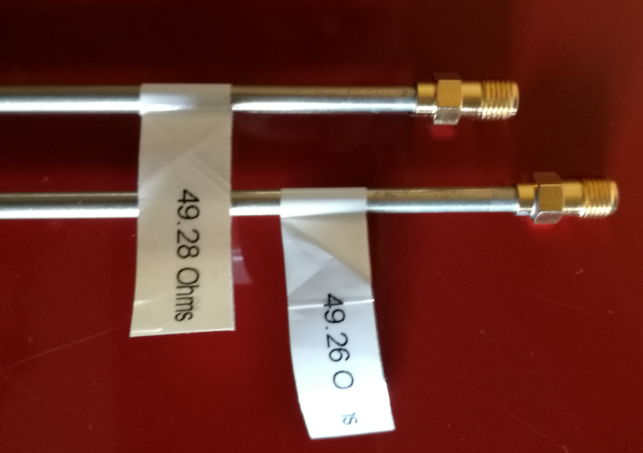

1. Go to the ‘Verify Calibration’ dialog, and choose the channel to be verified, by using the pull-down box in the upper left corner. Press the ‘Verify’ button. You should see the measured impedance in the ‘Measured Impedance’ field. The dialog will look similar to the picture below.



Note - the graph must be flat to assure the airline is still in good condition, and the value of the read impedance should match closely the label value on the semi-rigid standard.

This value should correspond to the value marked on the airline with the tolerance of the instrument. Being the tolerance 1%, we considered that the measured value is acceptable if the difference with the marked value is within +/- 0,5 ohm (1% on 50ohm).

In our example we have used a reference airline with marked value of 49,26 and we got a reading of 49,55, which means a difference of 0,29ohm which is within the 0.50 ohm of tolerance. Our system could be considered within calibration.

If we find a value exceeding the 0,50ohm difference , we need to contact the factory for further examination of the instrument.

***Differential Channels Calibration***

The above procedure is valid also for the Differential Channels with a little difference.

Choose to calibrate the Differential Channels. You need to have 2 cables connected to the 2 differential channels.

As before, remove probes or airlines connected to the cables and do the ‘Find End of Cable’.

Then connect both semi-rigid standards, one for each cable.

Click on VERIFY.

As before you will get a flat graph and a MEASURED IMPEDANCE value. You will notice that this value is now close to 100ohm.

For your evaluation, this value should be matching the SUM of the 2 values marked on the 2 airlines always considering the tolerance of 1%. Because it is now 1% over 100ohm, the acceptable difference will be now +/-1ohm.

Thus if the difference between the MEASURED VALUE and the SUM of the 2 airlines values is within 1ohm, the system could be considered calibrated.

If not, then you will to contact the factory for further examination of the instrument.

1. ***ESD***

** Know your enemy!**

**ESD is a killer for every TDR. ST-series is less sensitive to ESD damage than any other TDR, but it is not indestructible.**

**With some precautions like wearing the wrist strap and being mindful of the things that generate ESD you can make the life of your instrument much longer.**

**Electrostatic Discharge**, or **ESD**, is a single-event, rapid transfer of electrostatic charge between two objects, usually resulting when two objects at different potentials come into direct contact with each other. ESD can also occur when a high electrostatic field develops between two objects in close proximity. ESD is one of the major causes of device failures in the semiconductor industry.

Electrostatic charge build-up occurs as a result of an imbalance of electrons on the surface of a material. Such a charge build-up develops an electric field that has measurable effects on other objects at a distance. The process of electron transfer as a result of two objects coming into contact with each other and then separating is known as ‘triboelectric charging'.

## Examples of Static Generation

Typical Voltage Levels - Means of Generation 10-25% RH 65-90% RH

* Walking across carpet 35,000V 1,500V
* Walking across vinyl tile 12,000V 250V
* Worker at bench 6,000V 100V
* Poly bag picked up from bench 20,000V 1,200V
* Chair with urethane foam 18,000V 1,500V

[ESD controls](http://www.siliconfareast.com/esdcontrols.htm) may be classified into three major categories: 1) prevention of static charge build-up; 2) safe dissipation of any charge build-up; and 3) improvements in the ESD robustness of the product. The second category is very closely related to, and may sometimes even be indistinguishable from, the first category. Safe dissipation of accumulated charge involves the provision of a suitable electrical path that will allow charges to flow to ground. No ESD control program will be successful without a sound policy on grounding. As much as possible, there should only be one common ground for the entire factory.

Everything in the production line, from equipment to work tables to cabinets and racks, should be connected to this common ground. If the factory uses conductive flooring, then this should also be connected at regular intervals to this common ground. Having a single or common ground will ensure that everything in the production floor will remain at the same potential. Any charge build-up will immediately be dissipated by a good grounding system. The use of properly grounded wrist and foot straps or conductive shoes will also fall under this category, since these will bring any charge buildup on personnel to the common ground.

You may find more useful information on [www.easde.org](http://www.easde.org).